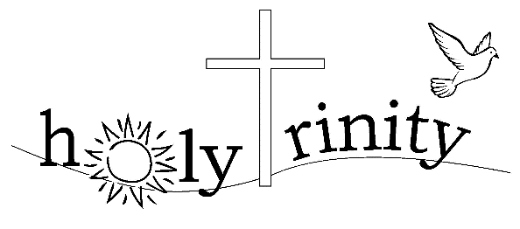
www.holytrinitybs.com

Holy Trinity Knitting Group
The group has not been able to meet together during the past year due to the pandemic. However, many of us have sought solace from loneliness in knitting at home. I have continued to deliver assorted knitwear to Linda Smith who works tirelessly for Felstead Aid. We look forward to getting together again for our weekly sessions in the church when deemed safe by the Government.
Carole Dedman

Social Group
We’ve had our moments on Zoom – Rachel’s beetle drive, plus quiz nights, Christmas carols, poetry readings, joke-telling etc. More to come when socialising is safe & stable again.
John Wrentworth

